Citing Sources in APA Style - 7th ed.
American River College Library, Updated 3/15/2022

While the ARC Library provides information on APA and MLA citation styles in order to support students, we support focusing on the goals of citation (acknowledging, and leading the reader to, sources) rather than on the mechanics. A number of readings have influenced our thinking. In particular, we are given pause by the work of Dr. Asao B. Inoue, who discusses the racial and class concerns associated with grading student work by how closely it approximates a particular style. We invite you to consider with us the costs and benefits of requiring that students produce “proper” or “error-free” citations and would welcome discussion.

This is a brief overview of how to cite sources using American Psychological Association (APA) style.
For more information, see:
- Publication Manual of the American Psychological Association (available at the Library’s Research Help Desk)
- ARC Library Citation Help webpage: https://arc.losrios.edu/student-resources/library/research/citation-help

Contents
In-Text Citations, page 2
One Author (or Editor), page 2
Two Authors, page 2
Multiple Authors (Three or more Authors), page 2
No Author, page 2
No Author, No Date, page 2
Entry in the DSM-V, page 2
Source Quoted in another Source, page 2
Direct Quotation (One page), page 2
Direct Quotation (Two or more pages), page 3
Paraphrase, page 3
Direct Quotations, page 3
Reference List, page 4
General Guidelines, page 4
Authors, page 4
Print Books, page 5
Online Sources, page 6
Formatting Guidelines, page 11
Elements of APA Format, page 11

Introduction to APA
In APA style, you acknowledge your outside sources in two ways:

In-Text Citations Overview
When you paraphrase or quote information that came from an outside source, you must tell your reader where the information came from. To do this, you provide brief information about the source, usually the author and publication year. If you use a direct quotation, you should also include the page number (see p. 3 for details).

Example:
While the opening of a large research university such as UC Merced leads to a growth in service industry jobs to meet the increased demands of students and faculty of the university, job growth in manufacturing is delayed (Lee, 2019).

Reference List Overview
You also need to provide a list of all of the sources that you cited in your paper. Here, you will give additional information about each source you cited. (See p. 4 for details).

Example:
Lee, J. (2019). The local economic impact of a large research university: Evidence from UC Merced. Economic Inquiry, 57(1), 316–332.

In-Text Citations
When you use ideas from an outside source by directly quoting or paraphrasing, give that source credit by including a brief citation. Every work you cite in-text should have an entry in your reference list, with the exception of personal communications or experiences. Always include a page number when citing direct quotations, and consider including a page number when paraphrasing complex ideas.

One Author (or Editor)
(Author’s Last Name, Year)
(Luna, 2020)

Two Authors
(Salas & D’Agostino, 2020)

Multiple Authors (Three or more Authors)
(Martin et al., 2020)

No Author
(“Title of Entry,” Year)
(“Understanding Sensory Memory,” 2018)

No Author, No Date
(“Title of Entry,” n.d.)
(“Questions and Answers,” n.d.)

Entry in the DSM-V
(American Psychiatric Association, 2013)

Source Quoted in another Source
(as cited in Zakharchenko, 2014, p. 99)

Direct Quotation (One page)
(Asante, 2014, p. 325)

Direct Quotation (Two or more pages)
(Risen, 2016, pp. 202-203)

Paraphrase
Paraphrasing involves restating the ideas of a source in your own words. It is recommended to paraphrase more often than directly quote in most academic writing. Include a citation for the paraphrased work in your text, and provide a page number in the citation when the paraphrased work is long or complex.

Parenthetical format places the citation in parentheses at the end of the sentence. When citing a source with two authors, use an ampersand (&) between the authors’ names.

Example:
Although Americans may say they are in favor of increased gun control, misperceptions about existing gun laws may lead to decreased action and advocacy (Arronow & Miller, 2016).
Narrative format includes the author’s name within the sentence. In this format, the date should be included just after the author’s name and the page number listed at the end of the sentence. When citing a source with two authors spell out the word “and” between the authors’ names.

Example:
According to Arronow and Miller (2016), although many Americans favor increased gun control, misperceptions regarding existing gun laws may lead to decreased action and advocacy.

Direct Quotations
If you use a direct quotation, you will put the quoted material in quotation marks (“ “), cite the source in parenthetical or narrative format as above, and also cite the page number in your in-text citation.

If the quotation appears mid-sentence, cite the source immediately after the quotation marks. Example:

One study found that both Latinos and Anglos who are involved in organizations “vote at impressively higher rates” (de la Garza, 2004, p. 97) than those who are not members of an organization.
If the quotation appears at the end of the sentence, cite the source in parentheses immediately after the quotation marks, and end with a period or other punctuation outside the final parenthesis. Example:

Strain and Webber (2017) argue that for women, “high-school leadership experience is correlated with occupational choice, specifically higher-income management occupations. Finally, we find that the gender wage gap is reduced by as much as 75 per cent when accounting for leadership experience among those within management occupations” (p. 5048).
If the quotation is 40 words or longer, omit the quotation marks. Start the quotation on a new line and indent the block of text ½ inch from the left margin. Double space the entire quotation. Example:

Children in the early years of school clearly link reading instruction with the classroom social environment:
Children’s perspectives documented in this study shed light on the multi-dimensional and variable nature of reading as a social practice in their early classroom lives. The children were clearly aware of the differentiation of their reading experiences according to the kinds of situations in which their reading was embedded. Children were attuned to situational variables such as roles and relationships, content focus and instructional emphasis, which shaped how children in various ways construed and participated in the seven situations explored in this study. (Harris, 2015, p. 35)

Reference List

General Guidelines
- Include citations only for sources that you personally read and actually cited in your paper.
- Citations should include the following elements: author, date, title, source. Examples below demonstrate variations based on source type.
- When listing authors’ names, include only the last name and initials. See the author formatting instructions below.
- Italicize book titles as well as periodical titles and volumes.
- Capitalize all words in a periodical title (e.g. Psychology Today) but only the first word in an article title, book title, or Web page (e.g. To kill a mockingbird). Also, capitalize the first word of a subtitle and capitalize proper nouns.

If a source (journal article, book, etc.) has a Digital Object Identifier (DOI), then include the DOI in the citation for both print and online versions

Authors

One Author
Harris, P. (2015).

Multiple Authors (up to 20)
List each author’s name. Separate the names with commas, add an ampersand (&) before the final name.
Fazilat, S.., Scherer, R., & Tondeur, J. (2016).

More than 20 Authors
List the first 19 authors, insert an ellipsis (…), then list the last author.
Wong, T. S., Harper, S., Coppola, N. K., Kornev, L., Fernandez, R., De La Cruz, P., … Hassan, Q. (2012).

Organization as an Author
American Psychiatric Association. (2013).

Print Books
- Basic Format for a Print Book
- Book with an Editor or Editors
- Chapter in an Edited Book
- Chapter in an Opposing Viewpoints Book
- Entry in an Encyclopedia (or other reference book)
- Entry in the DSM-V

Basic Format for a Print Book without a DOI
Author(s)’ Last Name(s), Initial(s). (Year of Publication). Title of book. Publisher.

Willmott, C., & Macip, S. (2016). Where science and ethics meet: Dilemmas at the frontiers of medicine and biology. Praeger.

Basic Format for a Print Book with a DOI
Author(s)’ Last Name(s), Initial(s). (Year of Publication). Title of book. Publisher. DOI

Book with an Editor or Editors
Editor(s)’ Last Name(s), Initial(s). (Ed. or Eds.). (Year of Publication). Title of book. Publisher.
Keeling, A., & Wall, B. (Eds.). (2015). Nurses and disasters: Global, historical case studies. Springer Publishing Company. https://doi.org/10.1891/9780826126733
Sze, J. (Ed.). (2018). Sustainability: Approaches to environmental justice and social power. New York University Press.

Chapter in an Edited Book
Author(s)’ Last Name(s), Initial(s). (Year). Title of chapter or entry. In Editor(s)’ Initial(s) Last Name(s) (Ed. or Eds.), Title of book (page numbers of chapter or entry pp. xxx-xxx). Publisher.
Chan, S. (2018). A brief history of Asian American activism and why it matters for environmental justice. In L. Nishime & K. D. Hester Williams (Eds.), Racial ecologies (pp.170-184). University of Washington Press.

Article in an Encyclopedia or Other Reference Book
Author(s)’ Last Name(s), Initial(s). Title of entry. (Year). In Editor(s)’ Initial(s) Last Name(s) (Ed. or Eds.), Title of reference book (xx ed., Vol. xx, pp. xxx-xxx). Publication City, State: Publisher.

With an author listed
Jorgensen, R. (2015). Facebook. In C. T. Anglim (Ed.), Privacy rights in the digital age (pp. 188-189). Grey House Publishing.

With no author listed
Scoliosis. (2017). In K. Jones (Ed.), Childhood diseases and disorders sourcebook. (4th ed., pp. 569-572). Omnigraphics.

Entry in the DSM-V (print version)
American Psychiatric Association. (2013). Title of section. In Diagnostic and statistical manual of mental disorders (5th ed., pp. xxx-xxx). American Psychiatric Publishing.
American Psychiatric Association. (2013). Central sleep apnea. In Diagnostic and statistical manual of mental disorders (5th ed., pp. 383-386). American Psychiatric Association.

Online Sources
- General guidelines for online sources
- Webpage
- Entire Website
- Online Video
- Wiki Article
- Online Newspaper Article
- Journal Article with a DOI
- Journal Article Without a DOI
- Opposing Viewpoints Database
- CQ Researcher Database
- Gale Virtual Reference Library Database
- Ebook
- Other Online Sources

General Guidelines for Online Sources
Below are examples for various online source types. Include as much of the requested information as is available. Consult the full APA 7th edition manual for sources not described. General guidelines:
- If there is no author, start the entry with the title.
- If there is no publication date, use (n.d.), which stands for “no date.”
- DOI or URL shorteners may be used. Check the link to ensure it takes you to the correct location.

For ebooks and online periodical articles found on the Web:
- If the source has a Digital Object Identifier (DOI), include it
- If the source does not have a DOI, cite the Web address for the source (URL).

For online periodical articles found through a library subscription database:
- If the article has a Digital Object Identifier (DOI), include it. If a DOI is not listed on your source, try searching the CrossRef website: https://www.crossref.org/
- If the article has no DOI, do not include a URL or database information. The reference should be the same as the reference for a print version of the work.

Basic Format for a Webpage
Author(s)’ Last Name(s), Initial(s). (Year, Month Day). Title of document. Site Name. http://URL

With an author
Brooks, K. J. (2020, February 4). Macy's to close 125 stores over the next three years. CBS News. https://www.cbsnews.com/news/macys-to-close125-stores-over-the-next-three-years/

With no author
US election 2020: What is a caucus and how do they work? (2020, February 4). BBC News. https://www.bbc.com/news/world-us-canada-51273719

With no date
National Nurses United. (n.d.) What employers should do to protect nurses from Zika. https://www.nationalnursesunited.org/what-employers-should-do-to-protect-rns-from-zika

Entire Website
If you are describing an entire website, but not referring to a specific fact or idea from the site, it is OK to simply list the URL in an in-text citation. You do not need to include it in your list of references.

Example:
The KhanAcademy website hosts excellent instructional videos on a variety of subjects (http://www.khanacademy.org).

Online Video (e.g. from YouTube)
Name of poster or creator. (Year, Month Day). Title of video [Video]. Name of Site. https://URL

Example:
Bank of America. (2016, November 28). How to set a budget and stick to it [Video]. YouTube. https://youtu.be/pZDxU74V924

Wiki Article (e.g. from Wikipedia)
Include the date of the current version of the entry. You will need to select “View history” on the page and use the date of the version you used. Most wikis will not include a date because the material has the potential to be edited frequently. Because of this, you should also include the retrieval date in the URL.

Wikipedia
Title of entry. (Year, Month Day). In Wikipedia. https://URL

Psychology. (2020, January 24). In Wikipedia. https://en.wikipedia.org/wiki/Psychology

Online Newspaper Article
If the article is from a news website that does not have an associated newspaper, use the format for a webpage on a news website instead of the format for an article (ex. HuffPost).

Author(s)’ Last Name(s), Initial(s). (Year, Month Day). Title of article. Title of News Source. http://URL
de León, C. (2020, January 13). The 10 most checked-out books in N.Y. Public Library history. The New York Times. https://www.nytimes.com/2020/01/13/books/ny-public-library-top-books-history.html

Journal Article with a DOI (Digital Object Identifier)
Author(s)’ Last Name(s), Initial(s). (Year). Title of article. Title of Periodical, volume(issue), page numbers. doi:xx.xxxxxxxxxx
Cataldo, D. M., Migliano, A. B., & Vinicius, L. (2018). Speech, stone tool-making and the evolution of language. PLoS ONE, 13(1), 1–10. https://doi.org/10.1371/journal.pone.0191071

Journal Article without a DOI (do not include the database information)
Author(s)’ Last Name(s), Initial(s). (Year). Title of article. Title of Periodical, volume(issue), page numbers.
Shinn, M., Gibbons-Benton, J., & Brown, S. R. (2015). Poverty, homelessness, and family break-up. Child Welfare, 94(1), 105–122.

Opposing Viewpoints Database
Opposing Viewpoints Database provides access to a variety of different content types. Below are examples for two of the most common.

Opposing Viewpoint Essay
Author(s)’ Last Name(s), Initial(s). (Year). Title of article. In Gale Opposing Viewpoints Online Collection. Gale. URL (Reprinted from Original title, date, Original source)
Sundar, S. S. (2017). Social media users must start checking online news sources. In Gale Opposing Viewpoints Online Collection. Gale. https://link.gale.com/apps/doc/KCQRIU467955724/OVIC?u=sacr73031&sid=OVIC&xid=e008361c (Reprinted from Why do we fall for fake news?, 2016, December 7, The Conversation)

Newspaper Article from Opposing Viewpoints
Hakim, D., & Mcintire, M. (2019, August 7). Long, faltering search for federal legislation on background checks. New York Times, p. A17(L).

Article from CQ Researcher Database
Author(s)’ Last Name(s), Initial(s). (Year, Month Day). Title of article. CQ Researcher, volume(issue), pp-pp.
Young, K. (2019, October 18). Health care debates. CQ Researcher, 29(37), 1-58.

Article from Gale eBooks
Author(s)’ Last Name(s), Initial(s). (Year). Title of article. In Editor(s)’ Initial(s). Last Name(s) (Ed. or Eds.), Title of reference book (xx ed., Vol. xx, pp. xxx-xxx). Publisher.
Alic, M. (2017). Endurance training. In T. Moy (Ed.), The Gale Encyclopedia of Fitness (2nd ed., Vol. 1, pp. 293-297). Gale.

Ebook
Treat ebooks the same as print books. If the book has a DOI or URL, include that at the end of the citation.

Author(s)’ Last Name(s), Initial(s). (Year of Publication). Title of book. Publisher. DOI or URL
Garrett, B. (2018). Empirical nursing: The art of evidence-based care. Emerald Publishing Limited.
Sternberg, R. (2017). Career paths in psychology: Where your degree can take you (3rd ed.). American Psychological Association. http://dx.doi.org/10.1037/15960-000

TED Talk
Author(s)’ Last Name(s), Initial(s). (Year, Month Day). Title of TED talk [Video]. Source. URL
Millman, D. (2019, December). How symbols and brands shape our humanity [Video]. TED Conferences. https://www.ted.com/talks/debbie_millman_how_symbols_and_brands_shape_our_humanity

Social Media Sources
Cite original content from social media sources. For articles found on social media, cite the source directly. For social media sources, follow the formats listed below.

Twitter and Instagram
Author(s)’ Last Name(s), Initial(s). [@username]. (Year, Month Day). Content of post up to the first 20 words [Description of audiovisuals]. Site Name. URL
Cosumnes River College [@ChooseCRC]. (2020, February 19). TODAY | Join us for today's OneBook, Black History Month event, "Restoring the Rights of Formerly Incarcerated Citizens" with Assembly member [Image attached] [Tweet]. Twitter. https://twitter.com/ChooseCRC/status/1230161787430899712
Holland, T. [tomholland2013]. (2019, August 22). We did it Mr. Stark! [Photograph]. Instagram. https://www.instagram.com/p/B1fUPgblShf/
Tyson, N. d. [@neiltyson]. (2020, February 8). Internet search engines have a way of affirming your hypothesis, no matter what you have hypothesized [Tweet] Twitter. https://twitter.com/neiltyson/status/1226279257049051141

Facebook and others:
Author(s)’ Last Name(s), Initial(s). (Year, Month Day). Content of post up to the first 20 words [Description of audiovisuals]. Site Name. URL
Name of Group [Username]. (Year, Month Day). Content of post up to the first 20 words [Description of audiovisuals]. Site Name. URL
Username. (Year, Month Day). Content of post up to the first 20 words [Description of audiovisuals]. Site Name. URL
Lawson, J. [The Bloggess]. (2020, February 14). Outside of Nowhere Bookshop right now: [Image attached]. Facebook. https://www.facebook.com/jennythebloggess/photos/a.10152310312171511/10156482246036511/?type=3&theater
New York Public Library. (2020, February 22). Get crafty with this free download from The New York Public Library Shop of the 125 Books We Love list! [Image attached]. Facebook. https://www.facebook.com/nypl/posts/10158101585597351?__tn__=-R

Formatting Guidelines
Note: The 7th edition of the APA Publication Manual provides alternative instructions for formatting student research papers from those used for formatting manuscripts. Guidelines and examples are listed below including for optional elements such as Running Head. Please refer to assignment instructions provided by your professor for guidelines on formatting your assignment.

Elements of APA Format

Margins, Font, and Spacing
The entire paper should have 1-inch margins, should be double-spaced, and typed in a standard, readable font size. APA recommends Times New Roman (12pt) or Calibri (11pt).

Title Page and Page Number
Some instructors may require a title page. If so, all elements should be centered, and the title should be placed three to four lines from the top of the page. Include an extra double-spaced line between the paper title and author names. The title page should include:
- Paper title
- Author names
- Author affiliation
- Course number and name
- Instructor name
- Assignment due date
- Page number (the page number should be included in the upper right corner on all pages including the title page)
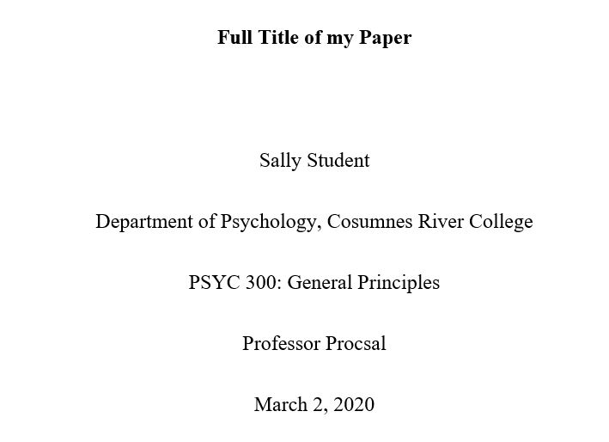

Running Head (optional element)
In the 7th edition guidelines, a Running Head is not required for student papers. If required by your instructor, follow these instructions.
- Use the header or page number functions of your word processing program to add the running head to the top left of the page. It should be in line with the page number.
- The running head should appear in all caps and should display the title of the paper.

Abstract (optional element)
Most student papers do not require an abstract. If your instructor requires an abstract, it should go on the page immediately following the title page. An abstract is a brief summary of your paper. It should be about a paragraph long. Center the word “Abstract” in bold at the top of the page, and begin typing your abstract on the next line. The paragraph should not be indented and It should be double-spaced.
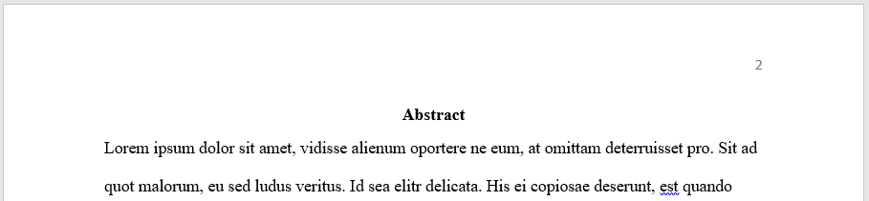

Body
If your paper requires an abstract, the body of your paper should begin at the top of the page following the abstract. If you do not have an abstract, the body should begin at the top of the page following the title page. Center the full title of your paper in bold print at the top of the body page and begin typing your paper on the next line. Be sure to indent each paragraph. Your entire paper should be double-spaced.
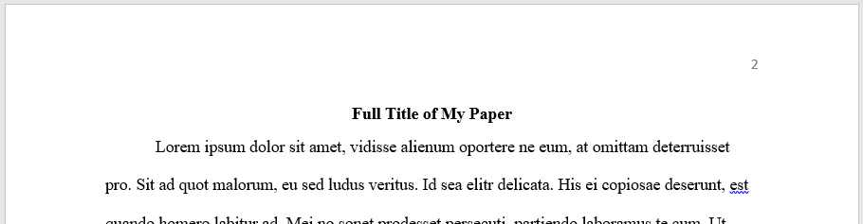

Headings
Use headings when necessary to differentiate distinct parts of a long or complex paper. Student papers may not require headings. Students should consult the 7th edition manual or APAStyle.apa.org for detailed instructions and examples of headings.

Reference List
- At the end of your paper and at the top of a new page, center the word References.
- Arrange your references alphabetically by author’s last name. For sources with no author, use the title to determine alphabetical placement.
- Double space the entire list. Apply “hanging indentation,” which means that for each entry, every line except the first line should be indented by ½ inch. (See below for instructions).

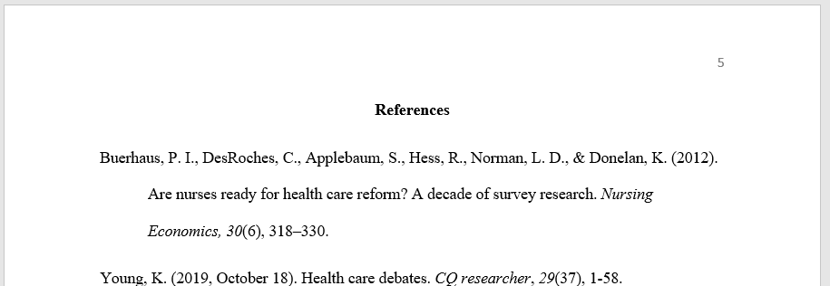

Creating a Hanging Indent in Microsoft Word
First, highlight all citations in your References list. Nex, use the Special indentation menu to select Hanging. This tool is available by expanding the Paragraph selections or the Line Spacing options.
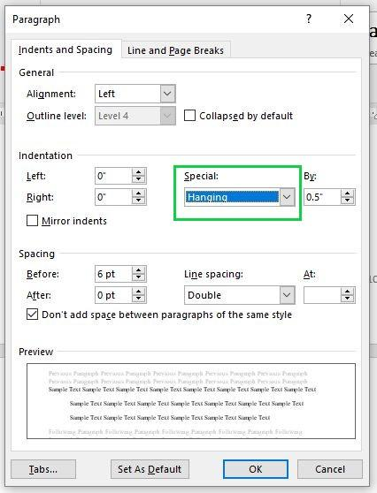

Click OK to save changes.

Creating a Hanging Indent in Google Docs
First, highlight all citations in your Works Cited list. Next, find the Left Indent (blue triangle) cursor in the document ruler and slide to the 0.5 inches mark. Then select the First Line Indent (blue rectangle) cursor in the document ruler and slide it back to the original position of 0 inches.

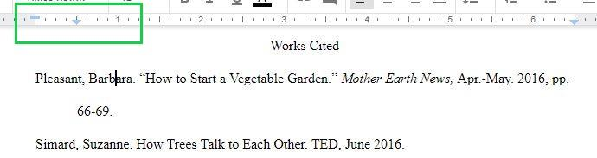

This guide was adapted from the Los Rios Community College Librarians (2020) by ARC Librarians (2022).
This guide is offered under a CC Attribution-NonCommercial-ShareAlike 4.0 International License

